**Guitar/Ukulele Tuition** 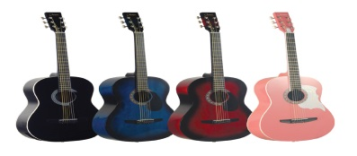

|  |  |
| --- | --- |
| Teacher | Mr Christian Everett |
| Instrument(s) | Acoustic, Electric and Bass guitars and ukulele and mandolin |
| Lesson Length | Thirty minutes |
| Lesson Type | Individual or small group |
| Cost | Individual Lesson:  30 minutes £20 per lesson  Group lessons (up to four pupils for 30 minutes):  £10 per pupil per lesson |
| Payment | In advance on receipt of an invoice for a block of lessons |
| Instrument available? | A guitar can be borrowed for the lesson, but cannot be taken home. |

**Lesson Terms and Conditions:**

Lessons are held one day a week (day to be confirmed). A lesson time and teacher will be allocated according to where space is available. The lesson time is arranged in conjunction with the student and their school timetable. Requests can be made for preferred lesson times, but these cannot always be accommodated. Priority for lessons in break/lunch/period 1 is given to Year 11 and 13 pupils.

All payment is to go directly to the instrumental teacher. **Please do not send money to the school office or give money to any other member of staff.** An invoice will be issued for payment in advance of lessons, directly from Mr Everett. Failure to make payment for the lessons will result in tuition being stopped.

**If you wish to end tuition please confirm this in writing/email giving a term’s notice.**

It is always helpful to know if a student is going to be absent, either by letting the instrumental teacher know if it is a planned absence, or for other unforeseen circumstances such as sickness, by getting a message to Miss Cox.

……………………………………………………………………………………………………………………..……………………………………………….

To Miss Cox Guitar/Ukulele Tuition

Name of student…………………………………………………………………………………..……………………….. Form……….……………

Instrument…………………………………………………………………………………………………………………………………………………....

Type of lesson required: (group or individual)……………………………………..………………………………………………………..

Left or Right handed?..........................................................................................................................................

Experience (please circle): Beginner Less than one year More than one year Grade 1+

**I have read and agree to the Terms and Conditions.**

Signed…………………………………………………………………………………………………………………..Date…………………..…………..

(Parent/Guardian)

Contact Telephone number……………………………………………………………………………………………………………………………

Email Address………………………………………………………………………………………………………………………………………………..